山东大学 软件 学院
算法分析与设计课程实验报告

学号： | 姓名： |  | 班级：
实验题目：单源最短路径算法
实验学时：4 |  | 实验日期：2018.12.25
实验目的：
深刻理解单源最短路径算法

硬件环境：
win10

软件环境：
win10、eclipse、jdk1.8

实验步骤与内容：
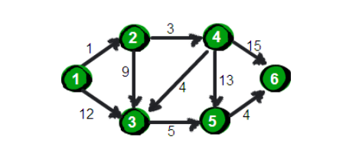
定义加权有向边数据类型
package sssp;
public class DirectedEdge {
private final int v;
private final int w;
private final double weight;
public DirectedEdge(int v, int w, double weight) {
this.v = v;
this.w = w;
this.weight = weight;
}
public double weight(){
return weight;
}
public int from(){
return v;
}
public int to(){
return w;
}
@Override
public String toString() {
return "DirectedEdge [v=" + v + ", w=" + w + ", weight=" + weight + "]";
}
}

定义加权有向图的数据类型
package sssp;
import java.util.LinkedList;
public class EdgeWeightedDigGraph {
private final int V;
private int E;
private LinkedList<DirectedEdge>[] adj;

public EdgeWeightedDigGraph(int v) {
V = v;
E = 0;
adj = new LinkedList[V];
for(int i =0;i<v;i++){
adj[i] = new LinkedList<DirectedEdge>();
}
}
public int V(){
return V;
}
public int E(){
return E;
}
public void addEdge(DirectedEdge e){
adj[e.from()].add(e);
E++;
}
public Iterable<DirectedEdge> adj(int v){
return adj[v];
}
public Iterable<DirectedEdge> edges(){
LinkedList<DirectedEdge> l = new LinkedList<DirectedEdge>();
for(int v =0;v<V;v++){
for(DirectedEdge e :adj[v]){
l.add(e);
}
}
return l;
}
}

定义索引优先队列
package sssp;
public class IndexMinPQ<Key extends Comparable<Key>> {
private int N;
private int[] pq;
private int[] qp;
private Key[] keys;
public IndexMinPQ(int maxN){
keys = (Key[])new Comparable[maxN + 1];
pq = new int[maxN+1];
qp = new int[maxN+1];
for(int i=0;i<maxN;i++){
qp[i] = -1;
}
}

public boolean isEmpty(){
return N==0;
}
public boolean contains(int k){
return qp[k] !=-1;
}
public void insert(int k,Key key){
N++;
qp[k] = N;
pq[N] = k;
keys[k] = key;
swim(N);
}
public Key min(){
return keys[pq[1]];
}
public int delMin(){
int indexOfMin = pq[1];
exch(1,N--);
sink(1);
keys[pq[N+1]] = null;
qp[pq[N+1]] = -1;
return indexOfMin;
}
public int minIndex(){
return pq[1];
}
public void change(int k,Key key){
keys[k] = key;
swim(qp[k]);
sink(qp[k]);

}
public void delete(int k){
int index = qp[k];
exch(index,N--);
swim(index);
sink(index);
keys[k] = null;
qp[k] = -1;
}
private void sink(int k){
while(2*k<=N){
int j = 2*k;
if(j<N&&less(j,j+1))j++;
if(!less(k,j))break;
exch(k,j);
k=j;

}
}
private void swim(int k){
while(k>1&&less(k/2,k)){
exch(k/2,k);
k = k/2;
}
}
private void exch(int i,int j){
int swap = pq[i];
pq[i] = pq[j];
pq[j] = swap;
qp[pq[i]] = i;
qp[pq[j]] = j;
}
private boolean less(int i ,int j){//i比j的优先级高
return keys[pq[i]].compareTo(keys[pq[j]])>0;
}
}

松弛这个术语来自于用一根橡皮筋沿着连接两个顶点的路径紧紧展开的比喻：放松一条边就类似于将橡皮筋转移到一条更短的路径上，从而缓解了橡皮筋的压力。边的松弛操作是一项很容易实现的重要操作，它是实现最短路径算法的基础。

Dijkstra 算法-权重非负
Dijkstra算法与prim算法类似，首先将distTo[s]初始化为0，distTo[]中的其他元素初始化为正无穷。然后将distTo[]最小的非树节点放松并加入到树中，直到所有的顶点都在树中或者所有的非树节点的distTo[]值为无穷大。索引优先队列pq用以保存需要被放松的顶点并确认下一个被放松的顶点，edgeTo[]中的元素所对应的可达顶点构成了一棵最短路径树。
权重非负的加权有向图单源最短路径Dijkstra 算法实现：

package sssp;
import java.util.ArrayDeque;
import java.util.Queue;
import spanTree.Prim;
public class Dijkstra {
private DirectedEdge[] edgeTo;
private double[] distTo;
private IndexMinPQ<Double> pq;
public Dijkstra(EdgeWeightedDigGraph G,int s){
edgeTo = new DirectedEdge[G.V()];
distTo = new double[G.V()];
pq = new IndexMinPQ<Double>(G.V());

for(int v =0;v<G.V();v++){
distTo[v] = Double.POSITIVE_INFINITY;
}
distTo[s] = 0;
pq.insert(s,0.0);
while(!pq.isEmpty()){
relax(G,pq.delMin());
}
}
private void relax(EdgeWeightedDigGraph G,int v){
System.out.println(v);
System.out.println("-----------------------");
for(DirectedEdge e : G.adj(v)){
int w = e.to();
System.out.println("遍历到的边"+w);
if(distTo[w]>distTo[v]+e.weight()){
distTo[w] = distTo[v]+e.weight();
edgeTo[w] = e;
System.out.println("权重需要更新"+distTo[w]);
if(pq.contains(w)){
System.out.println("更新了权重"+distTo[w]);
pq.change(w,distTo[w]);
}else{
System.out.println("插入新点的权重"+distTo[w]);
pq.insert(w,distTo[w]);
}
}
}
System.out.println("-----------------------");
}
public double distTo(int v){
return distTo[v];
}
public boolean hasPathTO(int v){
return distTo[v]<Double.POSITIVE_INFINITY;
}
public Iterable<DirectedEdge> pathTo(int v){
if(!hasPathTO(v)){
return null;
}
Queue<DirectedEdge> path = new ArrayDeque<DirectedEdge>();
for(DirectedEdge e = edgeTo[v];e!=null;e = edgeTo[e.from()]){
path.add(e);
}
return path;
}
public static void main(String[]args){
EdgeWeightedDigGraph G = new EdgeWeightedDigGraph(6);
G.addEdge(new DirectedEdge(0, 1, 1));
G.addEdge(new DirectedEdge(0, 2, 12));
G.addEdge(new DirectedEdge(1, 3, 3));
G.addEdge(new DirectedEdge(1, 2, 9));
G.addEdge(new DirectedEdge(3, 2, 4));
G.addEdge(new DirectedEdge(3, 4, 13));
G.addEdge(new DirectedEdge(2, 4, 5));
G.addEdge(new DirectedEdge(4, 5, 4));
G.addEdge(new DirectedEdge(3, 5, 15));
Dijkstra D = new Dijkstra(G,0);
for(int i =0;i<6;i++){
System.out.println(D.distTo(i));
System.out.println(D.pathTo(i));
}
}
}
得到如下结果
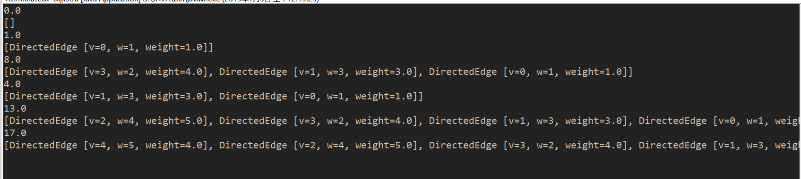
变种
- 加权无向图时：对于给定的加权无向图，创建一幅有相同顶点构成的加权有向图，并对与无向图中的每条边，相应地创建两条有向边。再按照如上算法求解即可。
- 给定起点s和终点t的最短路径：使用Dijkstra 算法并在优先队列中取到t之后终止搜索
- 任意顶点对之间的最短路径：构造Dijkstra 对象的数组，每个元素都将作为相应的顶点作为起点。所需时间与空间都与EVlogV成正比
package sssp;
public class DijkstraAllPairs {
private Dijkstra[] all;
DijkstraAllPairs(EdgeWeightedDigGraph G){
all = new Dijkstra[G.V()];
for(int v = 0;v<G.V();v++){
all[v] = new Dijkstra(G, v);
}
}
Iterable<DirectedEdge> path(int s,int t){
return all[s].pathTo(t);
}
double dist(int s,int t){
return all[s].distTo(t);
}
}
拓展
- 无环加权有向图最短路径算法：按照拓扑顺序放松顶点，就能在和E+V成正比的时间内解决无环加权有向图的单点最短路径问题，并能够处理负权重的边。具体实现
- 无环加权有向图单点最长路径算法：同最短路径算法，只不过将初始距离的初始值设置为负无穷小且放松方法中的不等式方向改变即可

Bellman-Ford
可能含有环也可能还有负权重的边的加权有向图中的最短路径算法。
首先我们先来看一下负权重环。当在研究含有负权重边的有向图时，如果该图含有一个权重为负的环，那么最短路径的概念就失去了意义，因为通过负权重环我们便可得到权重任意小的路径。
首先我们定义EdgeWeightedDirectedCycle类用来检测是否会有环
package sssp;
import java.util.ArrayDeque;
import java.util.Queue;
public class EdgeWeightedDirectedCycle {
private boolean[] marked;
private DirectedEdge[] edgeTo;
private boolean[] onStack;
private Queue<DirectedEdge> cycle;

public EdgeWeightedDirectedCycle(EdgeWeightedDigraph G) {
marked = new boolean[G.V()];
onStack = new boolean[G.V()];
edgeTo = new DirectedEdge[G.V()];
for (int v = 0; v < G.V(); v++)
if (!marked[v]) dfs(G, v);
}
private void dfs(EdgeWeightedDigraph G, int v) {
onStack[v] = true;
marked[v] = true;
for (DirectedEdge e : G.adj(v)) {
int w = e.to();
if (cycle != null) return;
else if (!marked[w]) {
edgeTo[w] = e;
dfs(G, w);
}
else if (onStack[w]) {
cycle = new ArrayDeque<DirectedEdge>();
DirectedEdge f = e;
while (f.from() != w) {
cycle.add(f);
f = edgeTo[f.from()];
}
cycle.add(f);

return;
}
}
onStack[v] = false;
}
public boolean hasCycle() {
return cycle != null;
}
public Iterable<DirectedEdge> cycle() {
return cycle;
}
}

对于任意含有V个顶点的加权有向图和给定的起点s，在最坏的情况下基于队列的Bellman-Ford算法解决最短路径问题（或者找到从s可达的负权重环）所需的时间与EV成正比，空间和V成正比

package sssp;
import java.util.ArrayDeque;
import java.util.Queue;
public class BellmanFord {
private double[] distTo; // distTo[v] = distance of shortest s->v path
private DirectedEdge[] edgeTo; // edgeTo[v] = last edge on shortest s->v path
private boolean[] onQueue; // onQueue[v] = is v currently on the queue?
private Queue<Integer> queue; // queue of vertices to relax
private int cost; // number of calls to relax()
private Iterable<DirectedEdge> cycle; // negative cycle (or null if no such cycle)

public BellmanFord(EdgeWeightedDigraph G, int s) {
distTo = new double[G.V()];
edgeTo = new DirectedEdge[G.V()];
onQueue = new boolean[G.V()];
for (int v = 0; v < G.V(); v++)
distTo[v] = Double.POSITIVE_INFINITY;
distTo[s] = 0.0;
// Bellman-Ford algorithm
queue = new ArrayDeque<Integer>();
queue.add(s);
onQueue[s] = true;
while (!queue.isEmpty() && !hasNegativeCycle()) {
int v = queue.poll();
onQueue[v] = false;
relax(G, v);
}
}
private void relax(EdgeWeightedDigraph G, int v) {
for (DirectedEdge e : G.adj(v)) {
int w = e.to();
if (distTo[w] > distTo[v] + e.weight()) {
distTo[w] = distTo[v] + e.weight();
edgeTo[w] = e;
if (!onQueue[w]) {
queue.add(w);
onQueue[w] = true;
}
}
if (cost++ % G.V() == 0) {
findNegativeCycle();
if (hasNegativeCycle()) return; // found a negative cycle
}
}
}
public boolean hasNegativeCycle() {
return cycle != null;
}
public Iterable<DirectedEdge> negativeCycle() {
return cycle;
}
private void findNegativeCycle() {
int V = edgeTo.length;
EdgeWeightedDigraph spt = new EdgeWeightedDigraph(V);
for (int v = 0; v < V; v++)
if (edgeTo[v] != null)
spt.addEdge(edgeTo[v]);
EdgeWeightedDirectedCycle finder = new EdgeWeightedDirectedCycle(spt);
cycle = finder.cycle();
}
public double distTo(int v) {
if (hasNegativeCycle())
throw new UnsupportedOperationException("Negative cost cycle exists");
return distTo[v];
}
public boolean hasPathTo(int v) {
return distTo[v] < Double.POSITIVE_INFINITY;
}
public Iterable<DirectedEdge> pathTo(int v) {
if (hasNegativeCycle())
throw new UnsupportedOperationException("Negative cost cycle exists");
if (!hasPathTo(v)) return null;
Queue<DirectedEdge> path = new ArrayDeque<DirectedEdge>();
for (DirectedEdge e = edgeTo[v]; e != null; e = edgeTo[e.from()]) {
path.add(e);
}
return path;
}
public static void main(String[]args){
EdgeWeightedDigraph G = new EdgeWeightedDigraph(6);
G.addEdge(new DirectedEdge(0, 1, 1));
G.addEdge(new DirectedEdge(0, 2, 12));
G.addEdge(new DirectedEdge(1, 3, 3));
G.addEdge(new DirectedEdge(1, 2, 9));
G.addEdge(new DirectedEdge(3, 2, 4));
G.addEdge(new DirectedEdge(4, 3, 13));
G.addEdge(new DirectedEdge(2, 4, 5));
G.addEdge(new DirectedEdge(4, 5, 4));
G.addEdge(new DirectedEdge(3, 5, 15));
BellmanFord B = new BellmanFord(G,0);
for(int i =0;i<6;i++){
System.out.println(B.distTo(i));
System.out.println(B.pathTo(i));
}

}
}
得到如下结果
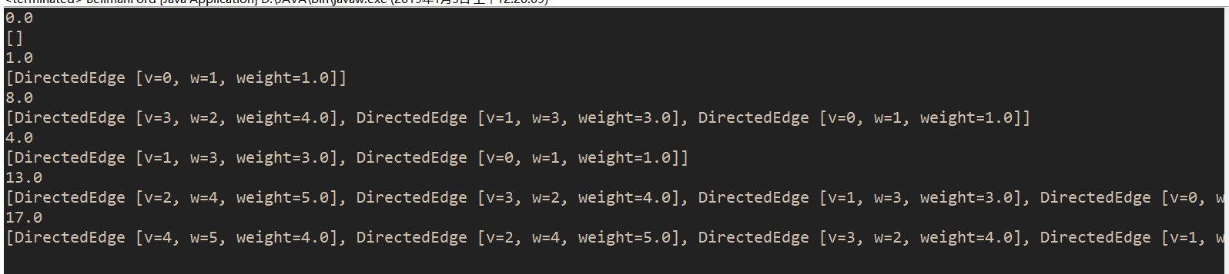
结论分析与体会：
通过此次试验，我进一步学习了最短路径算法，以及相对的不同方法的理解
算法 | 局限 | 路径长度的比较次数 |  | 所需空间 | 优势
算法 | 局限 | 一般情况 | 最坏情况 | 所需空间 | 优势
Dijkstra算法 | 边的权重为正 | ElogV | ElogV | V | 最坏情况下仍有较好的性能
拓扑排序 | 只适用于无环加权有向图 | E+V | E+V | V | 无环图中的最优算法
Bellman-Ford算法 | 不能存在负权重环 | E+V | VE | V | 适用领域广泛

